— Special Engagement —

What do current events in the Middle East have to do with the Kingdom of God –
and why should believers care? Fresh from the “prophetic Scriptures” emerge
ancient answers to modern-day questions that affect all people worldwide.

You’re Invited ~ to Come, Hear

. . . the revelation & prophetic significance of ISAIAH 19 for Egypt, Assyria &

Israel in the culmination of the grand scheme of all prophetic Scripture!

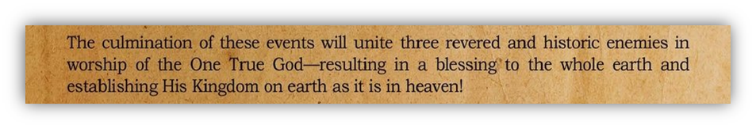

& Understand
. . . Father’s Heart for what it means for the Nations, Body of Messiah & You!

Presently based in Middle East, Tom & Teresa Craig have lived and served the Lord in Israel and the Middle East for over 25 years, building relational networks committed to worship & prayer across the entire region—and sharing His Word and the message of Isaiah 19 with the nations.

After recent trips to South Korea & Europe, they are here in Colorado to bless us
with His word to us— and the ISAIAH 19 revelation!

Friday, August 3rd
Doors Open 6:30 pm • Worship 7:00 pm

Gateway on Mt. Zion / Or Chaim

166 S. Lookout Mtn. Rd, Golden CO
www.gomz.org

*Amazon link for Book: http://a.co/8Qs0886

